|  |  |  |  |  |
| --- | --- | --- | --- | --- |
| |  | | --- | | Once upon a sign:Curriculum Guideline:The New Boy Who Cried Wolf | | Plot summaries:  Classic story: A shepherd-boy is on the watch for wolves, and he is to watch a flock of sheep at a village. He is bored and decides to tease the villagers. He calls out “Wolf! Wolf!”, and the villagers run over to help. They find out that he was teasing. They return to the village. The shepherd-boy decides to tease again, and again. Then, a wolf comes to the village, and the shepherd-boy finally means the cry out, but nobody believes him.   Once Upon a Sign story: A boy in an off-the-grid village is sent to the lookout to watch for Wolf, who takes the town’s healthy juice to market. When Wolf returns, the town will prepare for their annual celebration. Two times, the boy, “Small One,” makes a mistake and pulls the rope that alerts the town, causing them to prepare the celebration early. While the townspeople discuss Small One’s second mistake and reassure Small One that everyone makes mistakes, Wolf arrives unannounced. The town celebrates Wolf’s return with the profits from the sale of the juice. | | |  | | --- | | Class time26-minute videoBasic Comprehension:10-30 minutes  * **Advanced Learners: Approximately 2 class periods (100 minutes) for video viewing, basic comprehension activities, preparation and performance.** | |



**Basic Comprehension Procedure**

1. Introduce Story, discuss original story learned as a child, prepare students for “new” (different) version.
2. Show the video. If there is time, show the video (or parts of the video) twice.
3. Use Comprehension Questions to check for understanding
   1. Use as a quiz after the video, collect and grade

OR

* 1. Discuss questions as a class--use think, pair, share strategy for full engagement (give students 2-3 minutes to consider which answer they think is correct, 2 minutes to discuss with a partner, choose a student to answer).

1. Compare the “new” version with the original version. Note similarities and differences, especially the ending and moral of the story.

Answer Key

1.A 6. C

2.C 7. B

3.B 8. C

4.A 9. A

5.C 10. C



**Advanced Learner Procedure**

1. Complete Basic Comprehension Procedures
2. Using the guidelines described below, allow students 20 – 30 minutes to prepare their presentation for the class.

**Advanced Learner Activity**



Research the original story "The Boy Who Cried Wolf." Translate this version into ASL, sign and act it out. End this version by signing the moral of the story, "Never cry wolf." Include the meaning of the phrase, "Never cry wolf" in your translation.

**Once Upon A Sign**

**The “New” Boy Who Cried Wolf**

**Basic Comprehension Questions:**

1. **What does the city sell?**

A. Juice

B. Wool

C. Fruit

1. **Where do the ingredients come from?**

A. The North

B. The city

C. The Southwest

1. **If you drink the juice what happens?**

A. You gain magical powers

B. You become healthier and stronger

C. You become smarter

1. **Why does the town need someone to announce the return of Wolf?**

A. So they can prepare the feast

B. To warn of danger

C. To have time to move the sheep to safe pastures

1. **What is Wolf’s job?**

A. To eat the sheep

B. To bring food back to the village

C. To sell the juice

1. **What is the name of the boy chosen to look out for Wolf?**

A. Johnny

B. Little Boy

C. Small One

1. **From what direction will Wolf be coming?**

A. The North

B. The city

C. The Southwest

1. **How are the townspeople alerted to Wolf's return?**

A. A loud siren

B. The boy telling them

C. A red flashing alarm

1. **What signs are used for the phrase, "don't worry"?**
2. 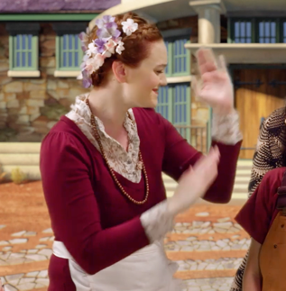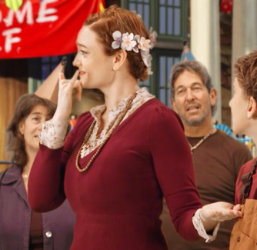
3. 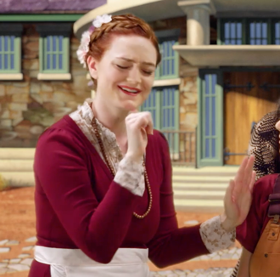
4. 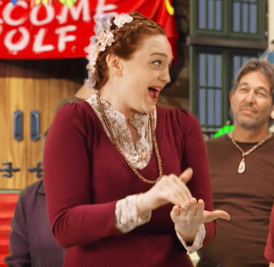

**10. Who actually first saw and reported Wolf's return?**

A. Tinker

B. The boy chosen to be on the lookout

C. The boy's little sister

