|  |  |  |  |  |
| --- | --- | --- | --- | --- |
| |  | | --- | | Once upon a sign:Curriculum Guideline:The New Goldilocks and the Three Bears | | Plot summaries:  Classic story: A family of three bears wake up to their morning routine. They make their hot breakfast bowls and go out on a walk before they come back to eat. As they step out, a blonde girl, who goes by the name Goldilocks knocks on the door and receives no answer. Goldilocks steps in the house and finds three hot breakfast bowls. Goldilocks tests them out and eats the one she likes the most. Goldilocks moves forward to testing out chairs, and she sits in the chair she likes the best until it collapses. Goldilocks ends up in a bed she likes the most. The three bears return home and find their things touched, and a woman sleeping in a bed. Goldilocks panics when she wakes up and runs out.   Once Upon a Sign story: A young girl named Goldilocks washes up on shore near the Three Bears’ house. The Three Bears make breakfast, but it’s too hot to eat. The Bears go for a walk. While they are out Goldilocks finds the house. While at the house alone she eats Baby Bear’s breakfast, breaks Baby Bear’s chair and falls asleep in Baby Bear’s bed. The Bears return home, discover the damage, and find Goldilocks in Baby Bear’s bed. When she wakes up she apologizes for the mess, and uses sign language to make the bed, and repair the damaged chair. When Goldilocks uses her magic, she and the Three Bears enjoy a feast for breakfast. | | |  | | --- | | Class time25-minute videoBasic Comprehension:10-30 minutes  * **Advanced Learners: Approximately 2 class periods (100 minutes) for video viewing, basic comprehension activities, preparation and performance.** | |



**Basic Comprehension Procedure**

1. Introduce Story, discuss original story learned as a child, prepare students for “new” (different) version.
2. Show the video. If there is time, show the video (or parts of the video) twice, while video is replaying have students copy the signing to increase fluency.
3. Use Comprehension Questions to check for understanding
   1. Use as a quiz after the video, collect and grade

OR

* 1. Discuss questions as a class--use think, pair, share strategy for full engagement (give students 2-3 minutes to consider which answer they think is correct, 2 minutes to discuss with a partner, choose a student to answer).

1. Compare the “new” version with the original version. Note similarities and differences, especially the ending and moral of the story.

Answer Key

1. B 6. C

2. C 7. A

3. A 8. B

4. B 9. B

5. A 10. A



**Advanced Learner Procedure**

1. Complete Basic Comprehension Procedures
2. Using the guidelines described below, allow students 20 – 30 minutes to prepare their presentation for the class.

**Advanced Signers Activity**



How does this version differ from the traditional Goldilocks and The Three Bears? Act out and sign the traditional Goldilocks and the Three Bears for your class.

**Once Upon A Sign**

**The New Goldilocks and the Three Bears**

**Basic Comprehension Questions:**

1. **Where do the Bears live?**

A. In the woods

B. By the coast

C. In a zoo

1. **Who prepared the morning feast?**

A. Daddy Bear

B. Mommy Bear

C. All three bears

1. **How do the bears sign “too hot to eat”?**

A. 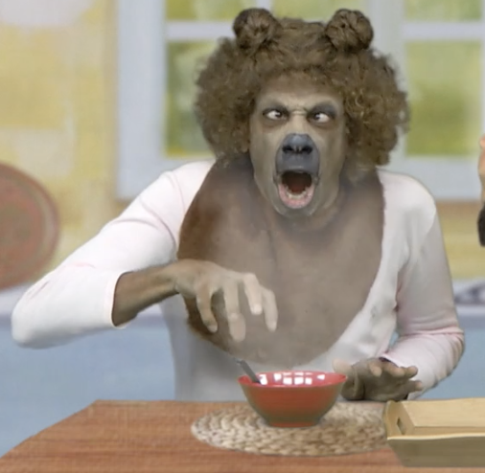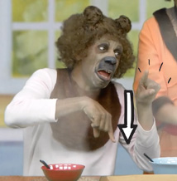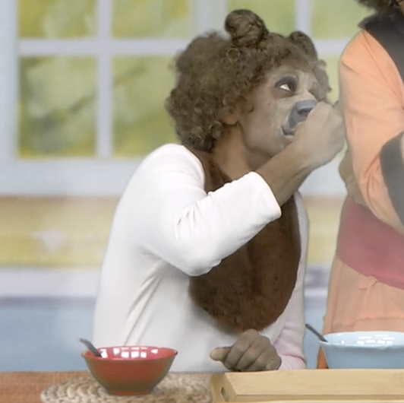

B. 

C. 

1. **Why does Baby Bear want to take a quick walk?**

A. He’s worried about someone eating his oatmeal

B. He’s hungry

C. He doesn’t like to walk

1. **Why doesn’t Baby Bear eat Mama Bear’s oatmeal?**

A. It’s not polite

B. He wasn’t hungry anymore

C. It was all gone

1. **Where do they find Goldilocks?**

A. Daddy Bear’s bed

B. Mama Bear’s bed

C. Baby Bear’s bed

1. **What does Baby Bear compare Goldilocks to?**

A. An angel

B. A human

C. A trespasser

1. **What is on the poster next to Baby Bear’s bed?**

A. Pictures of Baby Bear

B. The manual alphabet of ASL

C. A shelf with stuffed teddy bears

1. **What happens when Goldilocks wakes up?**

A. The Bear family scare Goldilocks away

B. Baby Bear gives her the name sign “Golden, Hair”

C. Goldilocks starts crying

**10. What happens when Goldilocks signs?**

A. Magic

B. They can’t understand her

C. She doesn’t sign, she talks

